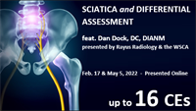

Rayus Radiology (formerly CDI) and the WSCA present the 2022 Dan Dock educational series. This year's two-part program is "Sciatica and Difference Assessment." Each part offers 8 CEs, for a total of 16 CEs. You do not have to attend Part A to attend Part B, but they are designed to be a package, so it's best if you attend both. Part A will be presented on February 17. Part B will be presented on May 5.
 | 2/17/2022
When: | Thursday, February 17, 2022  8:00am - 4:00pm Pacific
Where: | ONLINE  United States
Contact: | Jeff Curwen, CAE  wsca@chirohealth.org  206-878-6055

